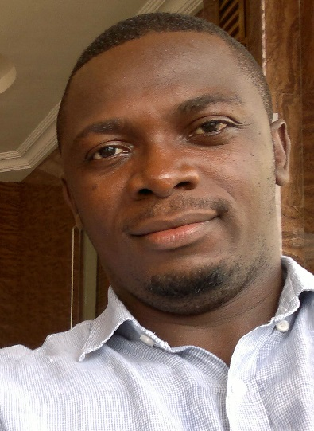 |  | AGBO EMMANUEL NNAMDI  HIGHER TECHNICAL OFFICER  Experience  HIGHER TECHNICAL OFFICER  UNIVERSITY OF NIGERIA, NSUKKA(DEPT. OF MATHEMATICS) ~ 2017 to date  Here is an overview of my experience and key achievements working for this institution.  - I have redesigned the departmental web site.  - Students of the department are now learning the use of mathematical software’s like Matlab, Maple, Latex etc.  TEAM LEADER (MARKET IMPACT TEAM)  AIRTEL NIGERIA,ENUGU STATE ~ 2010- 2012  Here is an overview of my experience and key achievements working for this company.  - My team was able to hit the 350,000 sim card registration mark within five months.  - I was able to resolve all technical issues with the systems used.  RESEARCH ASSISTANT  National identity management commission ~ 2008  Here is an overview of my experience and key achievements working for this company.  - I was able to collect quality data for analysis  Qualifications  B.Sc.(Hons) IN MATHEMATICS  University of Nigeria, Nsukka ~ 2004 - 2008  SENIOR SCHOOL CERTIFICATE EXAMINATION  Model secondary school, Nsukka. ~ 1995 – 2001  Skills - Good computing skills. - Strong technical skills in computing. - Good teaching skills. - Ability to work with others. - Very good in resolving ICT related issues. Interests - Learning - Acquiring skills - Being more productive at my place of work.  References  Available on request.
nnamdi.agbo@unn.edu.ng
08037701908
Rm 329, Dept. of Mathematics, University of Nigeria.
Nsukka
Enugu

