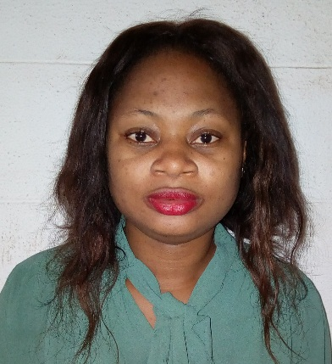 |  | OMEH CHINENYE  HIGHER TECHNICAL OFFICIER  Experience  Higher Technical Officier  University of Nigeria Nsukka, Department of Mathematics~ 2016 to date  Here is an overview of my experience and key achievements working for this company.  - Maintenance and Servicing of laboratory equipment.  - Instructor on the use of mathematical programming software’s.  Sales Supervisor  Redeemer Liveth Pharmacy Agbani Road, Enugu.~ 2013- 2015  Here is an overview of my experience and key achievements working for this company.  - Supervised sales operations of sales team.  - Supervised and oversee the maintenance of customer databases.  Mathematics Teacher  - Anglican Grammar School, Agbirigidi L.G.A, Oyo State(National Youth Service Corps )~2012  Qualifications  B.Sc. (Hons) Mathematics  Enugu State University of Science and Technology~ 2006 - 2011  A Levels  Command Day Secondary School,Abakpa Cantonment, Enugu.(WASC)~2002  Skills  - Good interpersonal skills  - Good computer skills  - Integrity and sincerity  - Able to work with little or no supervision.  - Do not have problem with new environment so long as life is not threatened.  Interests  Learning and Meeting people  References  Prof. G.C.E Mbah  Lecturer, University of Nigeria Nsukka.  08034198454  Pharm. (Mrs) Herietta Nwabuobi.  MD/CEO. Redeemer Liveth Pharmacy LTD  08060165516
Chinenye.omeh@unn.edu.ng
08062212812
No 15 Umuoyia Close ,Achara Layout Enugu.

Purityhealthshow.blogspotcom
Objective

To work in an establishment with high esteem, hard work, dedication, commitment,sincerity
,integrity and basically been an asset to the establishment.Also to work with high intellectuals that see problems as challenges.

