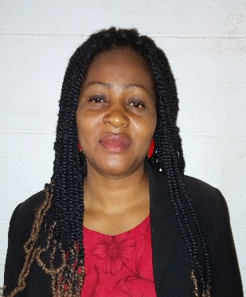 | EZE,EUCHARIA IFEOMA  Higher Technical officer  Department Of Mathematics,  University of Nigeria Nsukka.  Ifeoma.eucharia@unn.edu.ng
Mobile: 08037491037 | Objective
 | As a Technical Staff in Department of Mathematics, I specialize in Coaching (Academic) Staffs and students in Software Installations and Pakages.
 | Work experience
Higher Technical Officer,2017-date
University of Nigeria, Nsukka.

Mathematic Teacher,2012-2017.
Government Technical College, Nsukka.

Mathematics Teacher,2010-2012.
St,Catherine Secondary School,Nsukka.

Mathematics Teacher, 2007-2008.
Urban Boys Secondary School,Nsukka.
 | Education
M.Ed Measurement and Evaluation, 2017
Imo State University, Owerri
Professional Diploma in Education,2012.
The College of Education,Center for Professional Diploma in Education,Nsukka.

B.Sc Mathematics, 2007
University of Nigeria, Nsukka.

 | Skills
- Teaching
- Word Office
- MatLab

 | References
Prof. G.C.E Mbah
University of Nigeria, Nsukka
Nsukka
Enugu State

