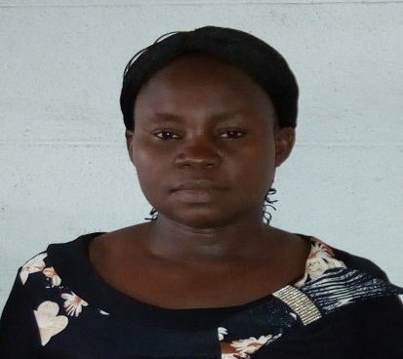 | EZEH ROSELINE ODINAKA  Trainee Computer Operator  Amugwu Obukpa Village,off Obukpa New Layout,Nsukka.  Roseline.ezeh@unn.edu.ng
Hobbies  Singing and reading books | Objective
 | My objective is to be a Proffectional Executive Officer.
 | Work experience
Trainee Computer Operator, 2017 – date
University of Nigeria Nusukka,faculty of Phsical Science.
A description of my job role and achievements goes here.
- Typing of Documents for the department.
- Ducumenting data and files for official duties
- Receiving mails.

Computer Operator As Causal Staff , 2003-2008
University of Nigeria Nsukka,faculty of Agriculture.
.

Personal Secretary, 1999-1992
University of Nigeria Nsukka,Department of PALG

 | Education
Senior Secondary Certificate Examination, 1996
Obukpa Community Secondary School

First School Leaving Certificate, 1986
Central School Okpuje,Nsukka

 | Skills
Microsoft Word - advanced
PowerPoint – advanced

 | References
Pastor P.C Aguwa
The Apostolic Church Obukpa,
Obukpa District,Nsukka

Prof. G.C.E. Mbah
Department of Mathematics
University of Nigeria, Nsukka

