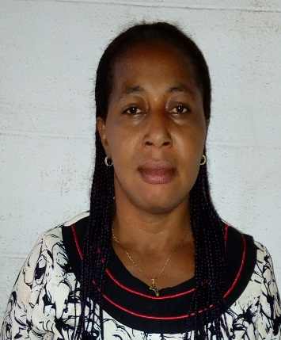 | NWODO DORATHY CHIGOZIE  Assistant Executive Officer.  Department of Mathematics,  University of Nigeria,Nsukka.  dorathy.nwodo@unn.edu.ng
Phone: 08035765032  L.G.A: Udenu  State: Enugu  Perm. Address: 86 Ogbelle Road, Ohullor Obolloa  Afor.  Cont. Address: No.1 Justina Eze Street, Ogurugu Road Nsukka.  Email: dorathy.nwodo@unn.edu.ng  Nationality: Nigerian | Objective
 | Contributing in Pilotting the affairs of the Department.
 | Work experience
Assistant Executive Officer,2016-date
Department of Mathematics
University of Nigeria,Nsukka

Senior Clerical Officer,2013-2015
University of Nigeria,Nsukka.

Clerical Officer,2008-2012
Dean’s Office,Faculty of Pharmaceutical Sciences,
University of Nigeria Nsukka.

Cashier,1994-1999
Kings Photo Company LTD,
Nsukka

 | Education
B.Ed ,Adult Education/Administration,2011-2015
University of Nigeria,Nsukka

N C E,Education Social Studies,2002-2006
National Teachers Institute,
Kaduna

SSCE,Senior School Certificate Examination,1985-1990
Community Commercial Shool,
Ede-oballa

FSLC,First School Leaving Certificate,1981-1985
Ubabari Pimary School,
Ede-oballa

 | Skills
Microsoft Word - advanced
PowerPoint – advanced

 | References
Prof, Anthony A. Attama
Department of Pharmacertical
08036618204

Prof.M O Oyesanya
Department of Mathematics,
University of Nigeria,Nsukka
08037717378

Prof.G C E Mbah
Department of Mathematics,
University of Nigeria,Nsukka.
08034198454

