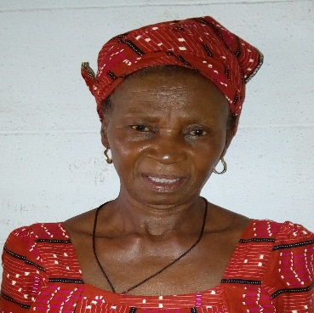 | OBAYI BENEDICTA OYODO  Cleaning Supervisor  No 10 Agbani Nguru, Nsukka.
Phone No:08068534329 | Objective
 | My objective is to work in the Institution with integrity and sincerityand to ensure that all area are kept sanitary.
 | Work experience
Cleaning Supervisor, 2000 – date

University of Nigeria Nusukka,faculty of Phsical Science.
A description of my job role and achievements goes here.
- Ensuring the offices are clean and in order.
- Delieving of mails to their respective places.

 | Education
 | First School Leaving Certificate, 1979
 | Skills
Good communicator.
Able to work without Supervision.
Integrity and Sincerity.

 | References

